County Councillor Update  Coker Division SCC  Cllr Mark Keating  August 2020 |  | 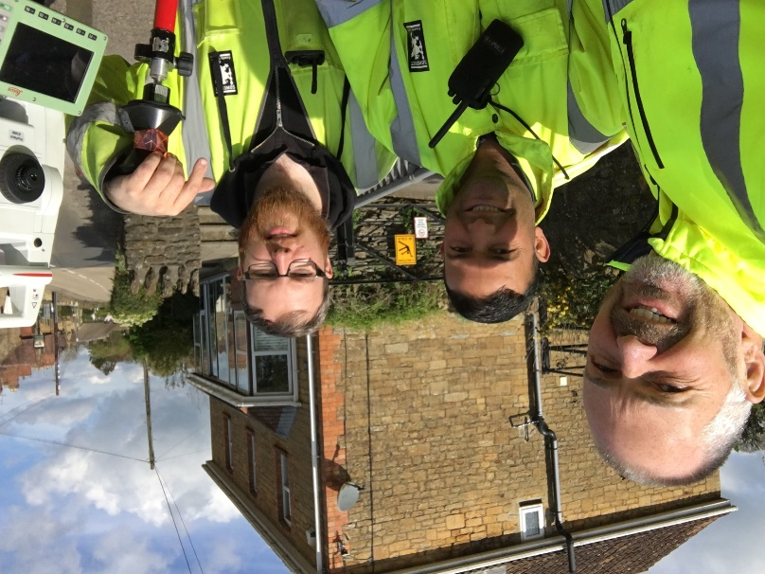
Representing you in - Barwick, Chiselborough, Closworth, East Chinnock, East Coker, Hardington Manderville, Hardington Marsh, Hardington Moor, Haselbury Plucknett, Middle Chinnock, Montacute, North Coker, North Perrott, Norton Sub Hamdon, ​Odcombe, Pendomer, Sutton Bingham, Stoford, West Chinnock, West Coker.
Useful Contacts Resources and Websites: Somerset Coronavirus Support Helpline: 0300 7906275
Cllr Mark Keating – Somerset County Council | E: MAKeating@Somerset.gov.uk | M: 07767 203968
South Somerset Area Highways Office | E: countyroads-southsom@somerset.gov.uk | T: 0300 123 2224
Report Pothole/Road Defect | E: roadsandtransportSD@somerset.gov.uk | T: 0300 123 2224
Report Dead Animal/Mud on Road | E: roadsandtransportSD@somerset.gov.uk | T: 0300 123 2224
Neil McWilliams – Highways Service Manager | E: countyroads-southsom@somerset.gov.uk | T: 0300 123 2224
Lee Norman/Derek Davies – Assist Highways Service Manager | E: countyroads-southsom@somerset.gov.uk | T: 0300 123 2224
Garry Warren/Rebecca Vaughan – Traffic Engineer. Traffic & Transport Development | E: countyroads-southsom@somerset.gov.uk | T: 0300 123 2224
Gully Emptying / Road Sweeper | E: chris.holley@southsomerset.gov.uk | T: 01935 462462
Nick Allen – SSDC Ranger Scheme | E: nick.allen@southsomerset.gov.uk | T: 01935 462462
Road Records & Highway Licensing | E: Roadrecords@Somerset.gov.uk | T: 0300 123 2224

Report Adult at Risk | adults@somerset.gov.uk |  |  | T: 0300 123 2224  T: Emergency: 999
Report Child at Risk | childrens@somerset.gov.uk |  |  | T: 0300 123 2224  T: Emergency: 999
Children’s Social Care Worker out of hours Emergency Duty Team |  |  |  | T: 0300 123 2327
Fostering and Adoption www.fosteradoptsomerset.org.uk | AandFRecruitmentEnquiryLine@somerset.gov.uk |  |  | T: 0800 587 9900
www.somersetwaste.gov.uk |  | ssdc@southsomerset.gov.uk | T: 01935 462462
https://www.travelsomerset.co.uk/ |  | Travel - Drive Bus Train Walk Cycle Weather
www.somerset.gov.uk |  | generalenquiries@somerset.gov.uk | T: 0300 123 2224
http://roadworks.org/ |  | Useful website for road works info
www.facebook.com/somersetcountycouncil |  | Somerset County Council Facebook page
https://roam.somerset.gov.uk/roam/map |  | Interactive Rights of Way Map / maintenance reporting

Corona Virus Update: Whilst every death is undoubtedly an absolute tragedy, the situation in Somerset has been throughout the pandemic relatively quiet compared to the rest of the Country. As at 30th July, the number of confirmed Covid cases in Somerset was 1308 and the number of Covid-attributed deaths 201. There have been no further Care Home deaths since 3rd July and the current number of total deaths across the County is currently 12% below the 5-year average. The latest R value for Somerset is between 0.8 and 1.1.
Covid 19 Outbreak Management: The Local Outbreak Engagement Board has met for the first time and agreed the Local Outbreak Management Plan. This Board will oversee the public engagement should any local lockdown actions be required. The Government has also passed down powers to the local authority to close premises, restrict open spaces and ban events in instances where the number of infections begins to rise sharply.
Covid 19 Business Survey: Somerset are undertaking a business survey to assess the impacts of COVID-19 (coronavirus) on the economy and will provide vital intelligence to help support local business response and recovery work. This survey forms part of a package of intelligence gathering being undertaken on the business and labour market impacts of the COVID-19 pandemic, working in partnership with business leaders and stakeholders across the county. The survey can be accessed online at www.somerset.gov.uk/businessrecoverysurvey until 14 August. Businesses can be reassured that their data will not be shared and all responses will be completely anonymised.
One Somerset: The business case to move to a Single Unitary authority across Somerset is available on http://www.onesomerset.org.uk and details the reasons for the recommendations and the substantial benefits to the residents of Somerset. The business case was approved by Full Council on the 29th July for submission to the Secretary of State. Engagement and consultation activities on One Somerset will continue through the later summer and autumn.
AV1 Learning Robots: Somerset County Council’s trail-blazing use of robot technology, to help poorly children learn, is in line for a top national award. In the biggest initiative of its kind in the country, the Council invested in 50 AV1 robots to support children who can’t be in school – whether it’s because they are sick or overcoming physical or mental health challenges. Now the project has been shortlisted in the Digital Transformation category of the national MJ Awards 2020. The winner is due to be announced in early October. Since being introduced late last year, 45 schools have already asked to use a robot to support children who cannot physically be in the classroom, including through the Covid-19 crisis. SCC expects that in the new school year students who are still required to shield due to the Covid-19 situation will benefit hugely from the AV1 Robot scheme.

Library Services: The County’s Library service now allows people to use an online request form to receive a selection of up to 10 books, DVDs or Talking Books which staff pick out for customers, based on the types of authors or genres that are of interest to them. The service originally operated from Taunton, Frome, Yeovil, Minehead and Bridgwater libraries and has had nearly 900 order and collect requests. From the 27 July, this was extended to Wells, Dulverton and Ilminster and from the 3rd August, Burnham-on-Sea, Williton, Wincanton and Shepton Mallet. South Petherton Community Library will be doing the same from the 4th August. Computers in the libraries need to be pre-booked and are available for one-hour slots, with time built in for cleaning. To date over 520 sessions have been booked. All current loans that would have been due back during the lockdown period have been extended to the end of August, and any overdue charges have been waived.
Domestic Abuse Service: Somerset County Council’ domestic abuse service is to receive a share of a half million-pound fund to support local services. The Council’s service provider, The You Trust, is one of a number of local agencies who help victims of domestic abuse and sexual violence, which will benefit from the fund. The You Trust are often the first point of contact for someone who is seeking help and the recent lockdown had a significant impact on victims who were living with perpetrators and felt that there was no way to escape. Help is available – 0800 69 49 999 or www.somersetsurvivors.org.uk
Maternity Toolkit: The newly launched Somerset Maternity Toolkit developed by Somerset County Council and the wider Local Maternity System offers a digital guide designed to support the beginning and early part of the maternity and parenting journey. It then leads supportively onto the Parent Carer Toolkit for parents/carers of school age children and young people. The service can be accessed 24/7 from home or on a smartphone on https://cypsomersethealth.org/maternity_toolkit

